Algorithm Analysis - Asymptotic Algorithm
What is a Notation?
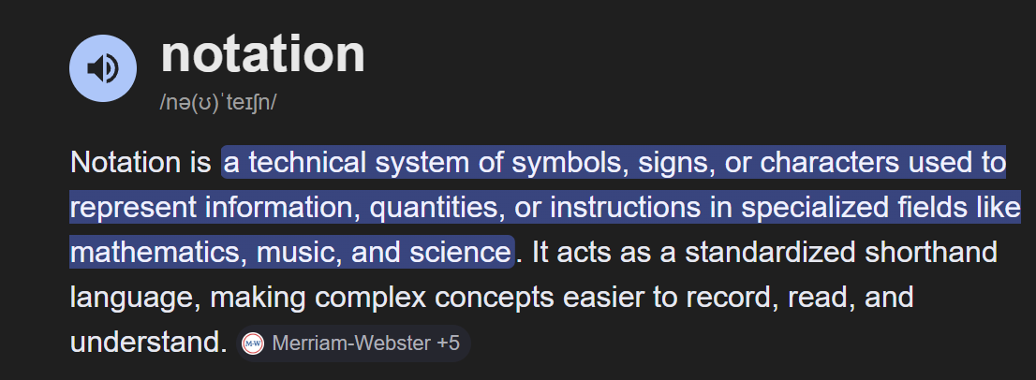
Simplest shapes of notations
numbers | 1,2,3,4
Sign | + - / *
Placholders | X,y

Big O notation
Growth rate of a function
Order of a function
fun(n) = n² – 3n + 1
n 🡺 ∞
x approaches infinty
f(n) asymptotically equivalent to n² as n approaches to infinty
n² 🡺 4 * 4 = 16
3n => 3 * 4 = 12
1 X
f(n) asymptotically equivalent to n² as n approaches to infinty
In work 🡺 o(n²)
Example: Sum of numbers from 1 to n
n = 5
1 + 2 + 3 + 4 + 5 = 15

function sum(n) {  var sum =0;  for (var i = 1;i <= n; i++) {  sum += i;  }  return sum;  } | f(n) = 1 + n + 1 + 1  n  asymptotically equivalent n as n approaches to infinity  or  O(n)
var sum = 0; | 1
for (var i = 1;i <= n; i++) {  sim += i;  } | n
return | 1
sum += i; | 1
function sumit(n) {  Var sum = n * (n + 1 ) / 2;  return sum;  }  Ask ChatGPT | Loop version n time O(n)  Forumla version once O(1)
f(n) = 1 + 1
f(n) = o(1) as n 🡺 ∞
o(1)

Notation | Pronunciation | Name In Math | Rate Excellent
O(1) | Oh one | Constant | Excellent
O(log₂n) OR log_{n} | Oh log n | logarithmic | Good
O(n) | Oh n | Linear | Fair
O(nlog_{n}) | Oh n log n | --------- | Bad
O(n)² & o(n)³ | Oh n square & oh n cube | Quadratic & cubic | Worst
O(2^{n}) | Oh two power n | Exponential | Worst
O(n!) | Oh n factorial | ------ | Horrible
Complexity classes
[formal name]
Complexity categories  [informal name] | 10!  1 * 2 * 3 * 4 * 5 * 6 * 7 * 8 * 9 * 10
Labels
[informal name]

What is Logarithmic STAY TUNED

My notes:
Notation is a formal way to represent something with symbols
The big O notation is another notation but it describes how fast a function grows?
- Equation f(n)= n2-3n+1 as it says that n approaches infinity, it means imagine the input getting bigger and bigger at that point the n2 part will dominate the 3n and +1
- If n=4 the n2 term is 16 and the 3n is only 12 and the constant 1 is tiny
- Saying that the function is asymptotically equivalent to n2 meaning that n2 is the most equivalent in the equation
- Big O keeps the dominant term and ignores constants and smaller terms
  - N2-3n+1 becomesO(n2)
  - 5n +100 becomes O(n)
  - 7 becomes O(1)
- The sum=0 is counted as 1 because it happens once and it doesnt rely on n
- The for loop for (var i = 1; i <= n; i++) {
sum += i;}
- The sum+=i is counted as 1
  - This runs once on its own regardless of the n and the loop

- The return sum is counted as 1 because it happens once at the end
  - This is also a constant work one final action no matter how large n is so it is O(1)
  - sum=1+1=2

R and D

